**DAOA**

By Ron Stark

Advantzware, Inc.

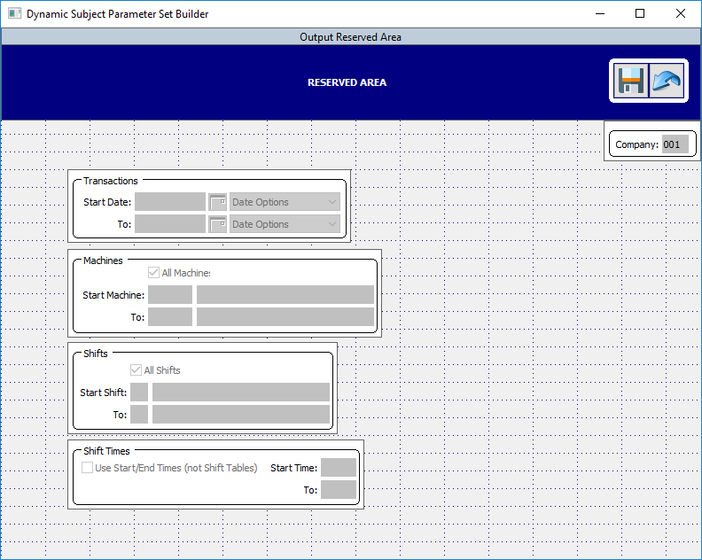

Dynamic Advantzware Open Analytics: Parameter User Guide

Table of Contents

Main Menu 5

Menu Options 5

Dynamic Parameter Builder [ND3] 6

Parameters [Tab] 7

▪ Restore Defaults 7

▪ Toggle Sort/Move Columns 7

▪ Search 7

▪ Yellow Labeled Columns 7

▪ Fields 7

• Update / Save 8

• Add 8

• Copy 8

• Delete 8

• Reset 9

• Cancel 9

• Auto Create a Parameter (View-As) 9

• Parameter Set Builder 9

Sets [Tab] 10

• Restore Defaults 10

• Toggle Sort/Move Columns 10

• Search 10

• Yellow Labeled Columns 10

• Fields 10

• Update / Save 11

• Add 11

• Copy 11

• Delete 11

• Reset 11

• Cancel 11

• Parameter Set Builder 11

Set Details [Tab] 12

• Restore Defaults 12

• Toggle Sort/Move Columns 12

• Search 13

• Yellow Labeled Columns 13

• Fields 13

• Update / Save 14

• Add 14

• Copy 14

• Delete 14

• Reset 14

• Cancel 14

• First 14

• Previous 14

• Next 14

• Last 14

• Parameter Set Builder 14

Refresh Defaults 15

Dynamic Subject Builder [ND2] 16

Sections 16

• Subject 17

o Fields 17

o Close (viewer) 17

o Update / Save 17

o Add 17

o Copy 17

o Delete 17

o Reset 17

o Cancel 18

• Table 18

• Where 19

• Columns 21

• Parameter Sets 24

• Run Subject 26

Main Menu Dynamic Subjects and Parameters allow for the creation of customized Parameter screens and Query Subjects which are data driven and can be constructed by non-developers to be utilized as Dynamic User Tasks.

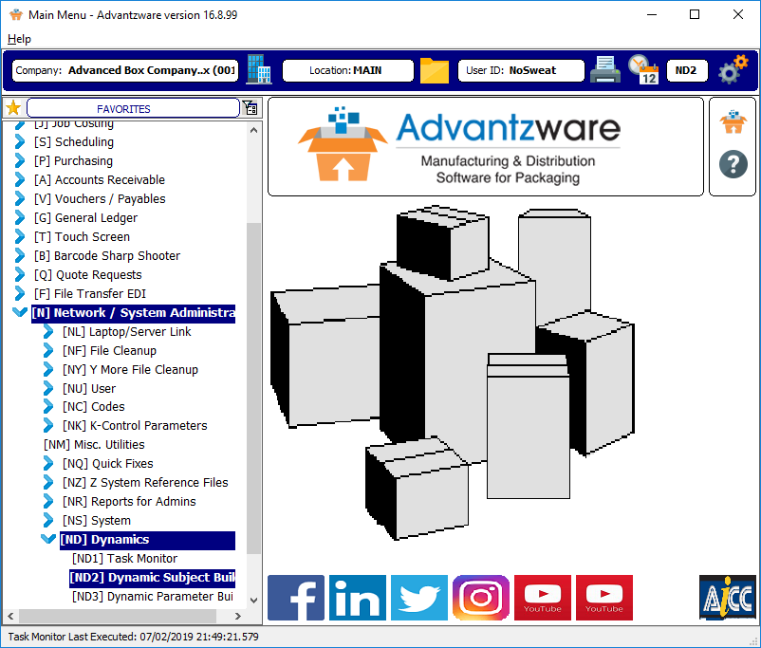

Menu Options

* **Network / System Administration [N] >**
  + **Dynamics [ND] >**
    - **Dynamic Subject Builder (ND2)**
    - **Dynamic Parameter Builder (ND3)**

Dynamic Parameter Builder [ND3] allows the construction of individual Dynamic Parameter object, which is used as the basic building component of creating a Dynamic Parameter Set. The screen position, the height and width can be custom set for each user. Screen sizing can be changed by dragging the edges in/out and/or up/down. The default Minimal size is 800x600.

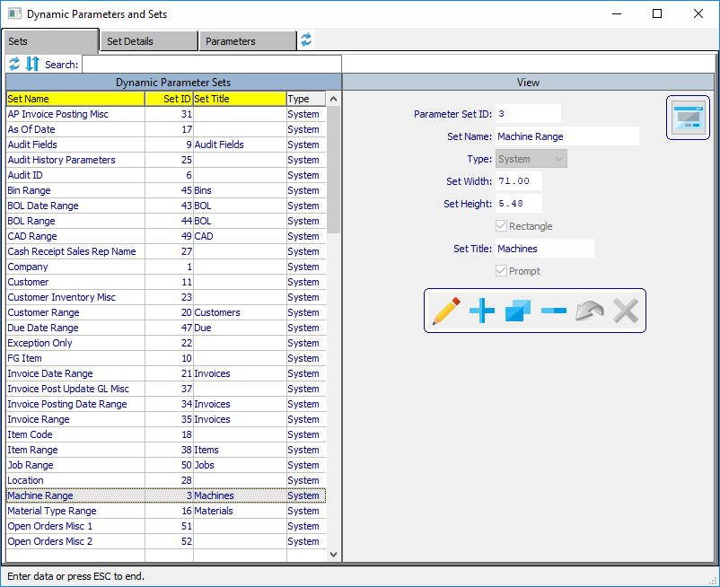

This module is best used by first navigating to the Parameters [tab], and first creating individual Dynamic Parameter(s). Return to the Sets [tab] to create a Dynamic Parameter Set and utilizing the Set Details [tab] to add individual Dynamic Parameter(s) to the Dynamic Parameter Set.

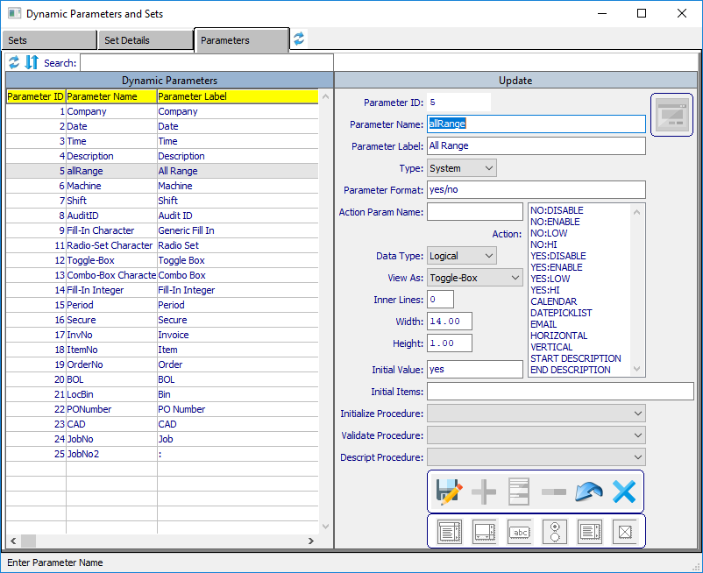

Parameters [Tab] is where an individual Dynamic Parameter is created, updated and/or deleted.

* Restore Defaults  restores the yellow column order to the original default order.
* Toggle Sort/Move Columns  /  , by default yellow columns will sort the data when the yellow column header is clicked, ascending and descending. Clicking to toggle this icon, changes from sort mode to allow a user to move and change the column order.
* Search will auto locate and filter records that match the entered criteria found in the yellow labeled columns.
* Yellow Labeled Columns sort a column ascending and/or descending when the column label is clicked.
* Fields
  + Parameter ID is auto generated when Saved after an Add and/or Copy.
  + Parameter Name is a free form entry and is used by other Dynamic Parameter’s Action Param Name field.
  + Parameter Label is a free form entry whose value appears to the left of a Dynamic Parameter object. Leave blank if no label is desired.
  + Type is either System or User. System indicates is was created and maintained by Advantzware internally and disturbed to client sites during upgrades. User types are those created by a client and custom to their internal uses.
  + Parameter Format is dependent on the Data Type, i.e., Character x(8), Date 99/99/9999, DateTime 99/99/9999 HH:MM:SS.SSS, Decimal ->>,>>9.99, Integer ->,>>>,>>9, or Logical yes/no.
  + Action Param Name is the value of another Dynamic Parameter’s Name used to trigger behavior designated by one or more of the Action values selected.
  + Action options with Name:Value selections apply when the value of Action Param Name value is changed, single Name only selections apply to the Parameter when it is initially rendered:
    - NO:DISABLE (if Action Param value is NO, parameter will disable)
    - NO:ENABLE (if value is NO, parameter will enable)
    - NO:LOW (if value is NO, parameter value is set to lowest value based on data type)
    - NO:HI (if value is NO, parameter value is set to highest value based on data type)
    - YES:DISABLE (if value is YES, parameter will disable)
    - YES:ENABLE (if value is YES, parameter will enable)
    - YES:LOW (if value is YES, parameter value is set to lowest value based on data type)
    - YES:HI (if value is YES, parameter value is set to highest value based on data type)
    - CALENDAR (will create calendar icon  to the right of the parameter)
    - DATEPICKLIST (creates combo-box picklist of data options to the right of the parameter)
    - EMAIL (creates plus icon  below the parameter label, for recipient’s selection popup)
    - HORIZONTAL (orients a radio-set parameter horizontally)
    - VERTICAL (orients a radio-set parameter vertically)
    - START DESCRIPTION (used to designate a parameter description with Start Range Value)
    - END DESCRIPTION (used to designate a parameter description with End Range Value)
  + Date Type options Character, Date, DateTime, Decimal, Integer or Logical.
  + View-As options Combo-Box, Editor, Fill-In, Radio-Set, Selection-List or Toggle-Box.
  + Inner Lines apply to View-As types Combo-Box, Editor and Selection-List and overrides the Height value.
  + Width indicates the width in characters of a Dynamic Parameter.
  + Height indicates the height in character of a Dynamic Parameter.
  + Initial Value sets the screen value when the parameter is displayed and must be a value in the Initial Value field to avoid an initialization error for Combo-Box, Radio-Set and Selection-List.
  + Initial Items is a comma delimited list of the value for a parameter and must be properly formatted for the various View-As types, which also can be dependent on the Data-Type.
  + Initialize Procedure contains a list of SUPER-PROCEDURES found in AOA/spDynInitializeProc.p which sets the initial value of a parameter, which is then overwritten if a value exists in a User’s Dynamica Parameter Value record.
  + Validate Procedure contains a list of SUPER-PROCEDURES found in AOA/spDynValidateProc.p to validate a value entered against the procedure’s logic.
  + Descript Procedure contains a list of SUPER-PROCEDURES found in AOA/spDynDescriptionProc.p which returns a character value based on the Action parameter it references.
* Update / Save  /  when the first icon is a pencil, will place the View into UPDATE mode and changes the icon to a floppy disk, when performs a SAVE operation, after which will change back to the pencil image.
* Add  creates a new blank record and generates a unique id when saved.
* Copy  create a copy of the currently selected record and generates a unique id when saved.
* Delete  will remove the selected record.
* Reset  when in Update/Copy mode will restore the field values of any changed fields to their original values.
* Cancel  when in Update/Add/Copy mode, will cancel the selected mode and return to View mode.
* 
* Auto Create a Parameter (View-As) when Combo-Box, Editor, Fill-In, Radio-Set, Selection-List or Toggle-Box is selected, the clicked View-As type is auto created and default values are set and placed into Add mode.
* 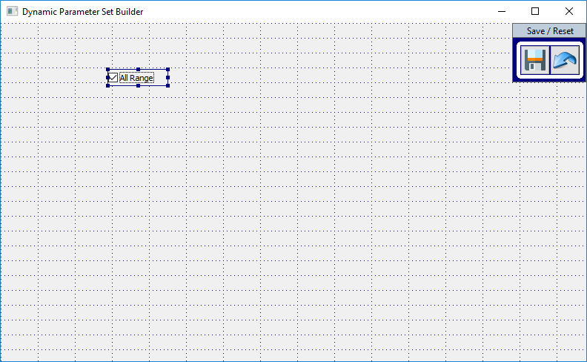
* Parameter Set Builder  accesses graphical builder that allows changes to height and width of the parameter, while also giving the ability to position the set parameters to the desired screen position.
  + **Save**  will enable if any changes are done to the Parameter object and Save those changes.
  + **Reset**  will enable if any changes are done to the Parameter object and Reset the prior values, then disable itself and the Save icon.
  + **Available Parameters (double click)** is a quick way of adding existing Dynamic Parameters to a set. The selected object will be positioned in the upper right corner. Simply drop and drag the parameter to the desired screen position.
* 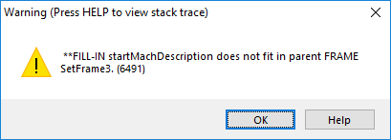
* **Note:** If a “does not fit in parent FRAME” error occurs, click OK and expand the set frame width, height or both values so the parameter causing the error can successfully fit.

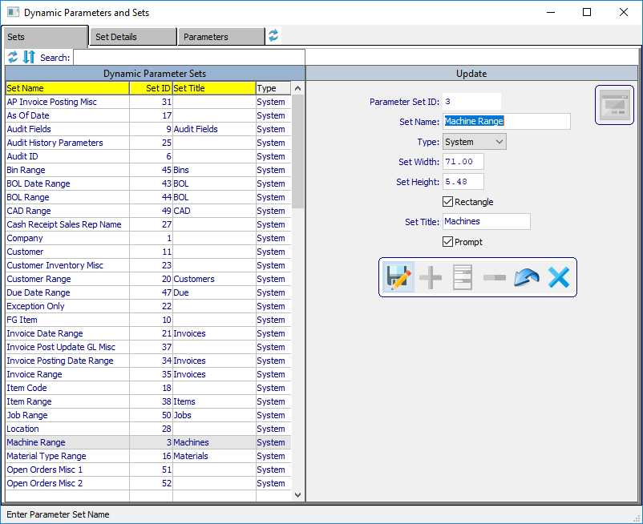

Sets [Tab] is where Dynamic Parameter Sets are created, updated and/or deleted.

* Restore Defaults  restores the yellow column order to the original default order.
* Toggle Sort/Move Columns  /  , by default yellow columns will sort the data when the yellow column header is clicked, ascending and descending. Clicking to toggle this icon, changes from sort mode to allow a user to move and change the column order.
* Search will auto locate and filter records that match the entered criteria found in the yellow labeled columns.
* Yellow Labeled Columns sort a column ascending and/or descending when the column label is clicked.
* Fields
  + Parameter Set ID is auto generated when Saved after an Add and/or Copy.
  + Set Name is a free form entry.
  + Type is either System or User. System indicates is was created and maintained by Advantzware internally and disturbed to client sites during upgrades. User types are those created by a client and custom to their internal uses.
  + Set Width of the frame.
  + Set Height of the frame.
  + Rectangle if selected creates a rectangle object the size of the set frame.
  + Set Title if populated will appear at the upper right corner of the rectangle. If there is no rectangle, the set title will not appear.
  + Prompt if selected allows data entry into the Dynamic Parameter object(s) contained within the set. If not selected, the set will visualize but render the objects disabled. Parameter Sets can be rendered invisible with a setting found within the Dynamic Subject the set is used.
* Update / Save  /  when the first icon is a pencil, will place the View into UPDATE mode and changes the icon to a floppy disk, when performs a SAVE operation, after which will change back to the pencil image.
* Add  creates a new blank record and generates a unique id when saved.
* Copy  create a copy of the currently selected record and generates a unique id when saved.
* Delete  will remove the selected record.
* Reset  when in Update/Copy mode will restore the field values of any changed fields to their original values.
* Cancel  when in Update/Add/Copy mode, will cancel the selected mode and return to View mode.
* 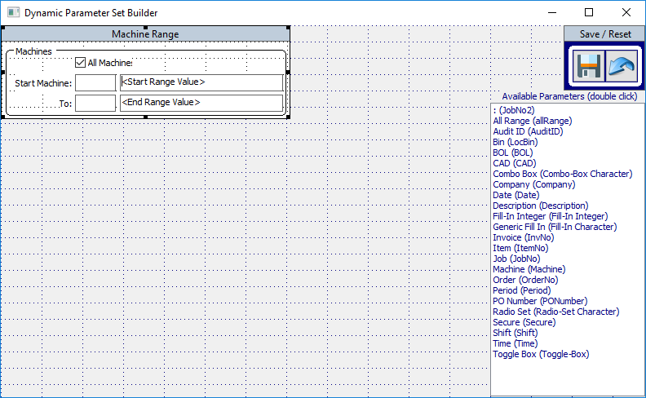
* Parameter Set Builder  accesses graphical builder that allows changes to height and width of the set frame, while also giving the ability to position the set parameters to the desired screen position.
  + **Save**  will enable if any changes are done to the Parameter object and Save those changes.
  + **Reset**  will enable if any changes are done to the Parameter object and Reset the prior values, then disable itself and the Save icon.
  + 
  + **Note:** If a “does not fit in parent FRAME” error occurs, click OK and expand the set frame width, height or both values so the parameter causing the error can successfully fit.

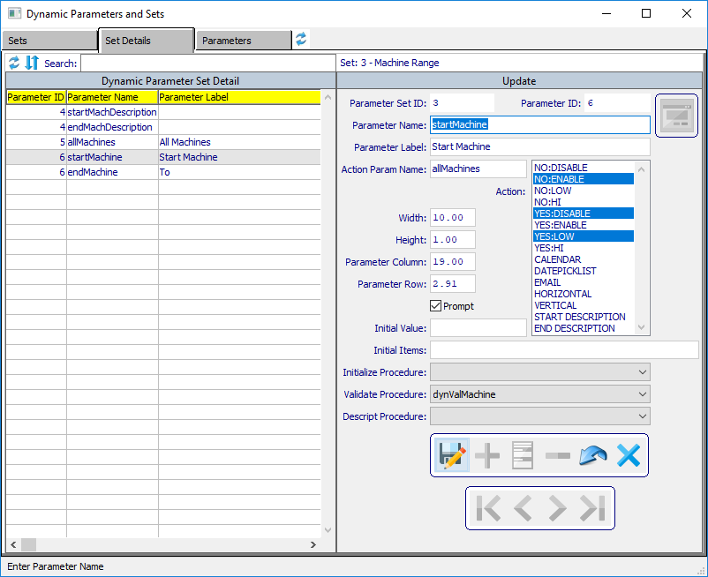

Set Details [Tab] is where Dynamic Parameters are assembled into a Dynamic Parameter Set. Sets are then used to construct a Dynamic Parameter Screen associated with Dynamic Subjects [ND2].

* Restore Defaults  restores the yellow column order to the original default order.
* Toggle Sort/Move Columns  /  , by default yellow columns will sort the data when the yellow column header is clicked, ascending and descending. Clicking to toggle this icon, changes from sort mode to allow a user to move and change the column order.
* Search will auto locate and filter records that match the entered criteria found in the yellow labeled columns.
* Yellow Labeled Columns sort a column ascending and/or descending when the column label is clicked.
* Fields during an Add operation all the fields will Auto load from the Parameter ID record. There values are found in the Parameters [tab] and act as default values. These values can be overwritten from the default values.
  + Parameter Set ID shows the Set ID selected from the Sets [tab].
  + Parameter ID is an existing Dynamic Parameter from existing parameters found in the Parameters [tab].
  + Parameter Name should be a unique value within the Parameter Set.
  + Action Param Name is the value of another Dynamic Parameter’s Name used to trigger behavior designated by one or more of the Action values selected. In the above example, startMachine is linked to allMachines. When the value of allMachines is changed, the logic scans for any selected Action(s) listed below. When allMachine toggle-box is checked, the Action values dictate that startMachine will Disable and set it’s screen value to the lowest value based on it’s data type. When allMachine is unchecked, startMachine will Enable and allow data entry.
  + Action options with Name:Value selections apply when the value of Action Param Name value is changed, single Name only selections apply to the Parameter when it is initially rendered:
    - NO:DISABLE (if Action Param value is NO, parameter will disable)
    - NO:ENABLE (if value is NO, parameter will enable)
    - NO:LOW (if value is NO, parameter value is set to lowest value based on data type)
    - NO:HI (if value is NO, parameter value is set to highest value based on data type)
    - YES:DISABLE (if value is YES, parameter will disable)
    - YES:ENABLE (if value is YES, parameter will enable)
    - YES:LOW (if value is YES, parameter value is set to lowest value based on data type)
    - YES:HI (if value is YES, parameter value is set to highest value based on data type)
    - CALENDAR (will create calendar icon  to the right of the parameter)
    - DATEPICKLIST (creates combo-box picklist of data options to the right of the parameter)
    - EMAIL (creates plus icon  below the parameter label, for recipient’s selection popup)
    - HORIZONTAL (orients a radio-set parameter horizontally)
    - VERTICAL (orients a radio-set parameter vertically)
    - START DESCRIPTION (used to designate a parameter description with Start Range Value)
    - END DESCRIPTION (used to designate a parameter description with End Range Value)
  + Width indicates the width in characters of a Dynamic Parameter.
  + Height indicates the height in character of a Dynamic Parameter.
  + Parameter Column is the column position of the parameter within the set frame.
  + Parameter Row is the row position of the parameter within the set frame.
  + Prompt if selected allows data entry into the Dynamic Parameter object. If not selected, the parameter will visualize but render the object disabled.
  + Initial Value sets the screen value when the parameter is displayed and must be a value in the Initial Value field to avoid an initialization error for Combo-Box, Radio-Set and Selection-List.
  + Initial Items is a comma delimited list of the value for a parameter and must be properly formatted for the various View-As types, which also can be dependent on the Data-Type.
  + Initialize Procedure contains a list of SUPER-PROCEDURES found in AOA/spDynInitializeProc.p which sets the initial value of a parameter, which is then overwritten if a value exists in a User’s Dynamica Parameter Value record.
  + Validate Procedure contains a list of SUPER-PROCEDURES found in AOA/spDynValidateProc.p to validate a value entered against the procedure’s logic. The above example has a value of “dynValMachine” which fires when a user leaves the startMachine parameter and executes the following code logic: CAN-FIND(FIRST mach WHERE mach.company EQ cCompany AND mach.m-code EQ iphWidget:SCREEN-VALUE) to ensure if the value entered is valid or not.
  + Descript Procedure contains a list of SUPER-PROCEDURES found in AOA/spDynDescriptionProc.p which returns a character value based on the Action parameter it references.
* Update / Save  /  when the first icon is a pencil, will place the View into UPDATE mode and changes the icon to a floppy disk, when performs a SAVE operation, after which will change back to the pencil image.
* Add  creates a new blank record and prompts for an existing Parameter ID.
* Copy  create a copy of the currently selected record.
* Delete  will remove the selected record.
* Reset  when in Update/Copy mode will restore the field values of any changed fields to their original values.
* Cancel  when in Update/Add/Copy mode, will cancel the selected mode and return to View mode.
* First  positions to the First record.
* Previous  positions to the Previous record relative to the currently selected record.
* Next  positions to the Next record relative to the currently selected record.
* Last  positions to the Last record.
* 
* Parameter Set Builder  accesses graphical builder that allows changes to height and width of the set frame, while also giving the ability to position the set parameters to the desired screen position.
  + **Save**  will enable if any changes are done to the set and Save those changes.
  + **Reset**  will enable if any changes are done to the set and Reset the prior values, then disable itself and the Save icon.
  + **Available Parameters (double click)** is a quick way of adding existing Dynamic Parameters to a set. The selected object will be positioned in the upper right corner. Simply drop and drag the parameter to the desired screen position.

Refresh Defaults  to original size and screen position, which are saved for each unique user when exiting.

Dynamic Subject Builder [ND2] allows for the creation of a data driven Dynamic Subject query, attaching front end data driven Dynamic Parameter screens created in Dynamic Parameter Builder [ND3].

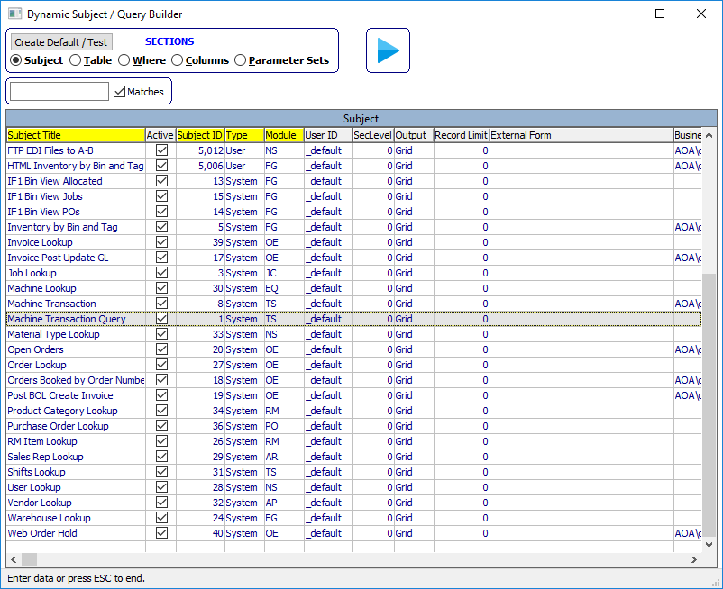

Search Filtering exists above the Subject Title. When Matches checked, the filter value will find the entered value anywhere within the Subject Title. If Matches unchecked, the logic performs a Begins against the Subject Title.

Sections allow access to the various components that make up a Dynamic Subject (subject header, table(s), where clause, columns (table fields) and parameter sets).

* 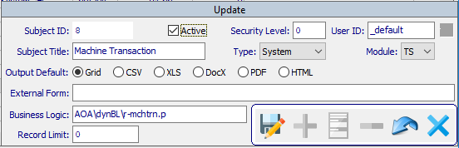
* Subject is the controlling information of a Dynamic Subject.
  + Fields
    - Subject ID is auto generated by either an Add or Copy upon a Save.
    - Active indicates is the subject is available for use to create Dynamic User Tasks.
    - Security Level is auto set based on the Security Level of the user and is used to control at what level a subject is available to other users based on their individual security level.
    - User ID is auto set based on the user that creates the subject and can be set to _default to indicate the base subject for Dynamic User Tasks.
    - Subject Title is a freeform field.
    - Type is either System or User. System indicates is was created and maintained by Advantzware internally and disturbed to client sites during upgrades. User types are those created by a client and custom to their internal uses.
    - Module options are AP, AR, DC, EQ, FG, GL, HS, JC, NS, OE, PO, RM, SB and TS.
    - Output Default options are Grid, CSV, XLS, DocX, PDF and HTML, which allows the subject to be run without the associated parameter screen.
    - External Form allows for the use of a custom created Jasper Report. By default the execution of a subject auto generates the Jasper Report .jrxml file. Populating this field will bypass the auto generation and use the designated form. The custom .jrxml report must be formatted correctly.
    - Business Logic is normally blank and relies on the query structure of table(s), where clause and columns. However, if the query results desired cannot be returned via a direct database query a
    - Coded .p (p-code) program can be used. These procedures are usually located in folder AOA/dynBL.
    - Record Limit when set to 0 (zero) will return all records in the query. Setting this value will limit the number of records returned and should be used for queries that may return a large dataset which may cause a significant delay.
  + Close (viewer)  closes the detail view when open.
  + Update / Save  /  when the first icon is a pencil, will place the View into UPDATE mode and changes the icon to a floppy disk, when performs a SAVE operation, after which will change back to the pencil image.
  + Add  creates a new blank record and Auto generates a Subject ID on a Save.
  + Copy  create a copy of the currently selected record and Auto generates a Subject ID on a Save.
  + Delete  will remove the selected record.
  + Reset  when in Update/Copy mode will restore the field values of any changed fields to their original values.
  + Cancel  when in Update/Add/Copy mode, will cancel the selected mode and return to View mode.

**Note**: Any changes done within the following 4 Sections (Table, Where, Columns and Parameters) will enable the Save  and Undo Changes  icons to the right of the Run Subject (play media) icon.

* 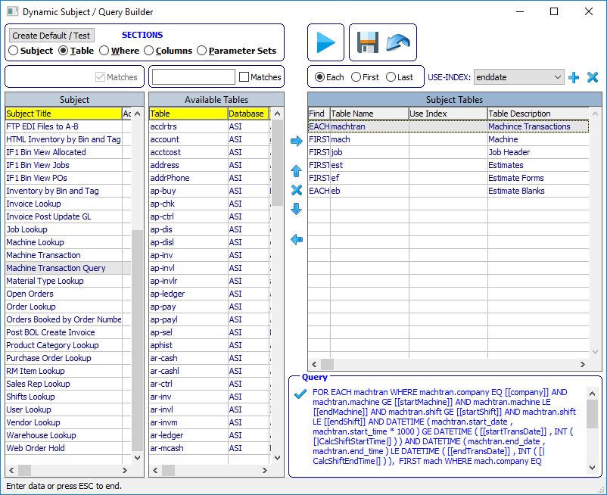
* Table section is where database table(s) are selected as part of the dynamic query, the table order and index usage (if needed).
  + **Table Find Type** options EACH, FIRST or LAST can be set for the selected Subject Table, except the first table of a query, which by default will always be EACH.
  + **Add Use Index**  will set the Use Index value and should be used if the default index usage does not give the desired results.
  + **Remove Use Index**  will remove a Use Index if one exists.
  + **Add Selections**  will add one or more of the selected Available Tables to the Subject Tables or simply double click an Available Table to auto add the table to Subject Tables.
  + **Move Up**  will move the selected Subject Table up in the query order.
  + **Remove**  will remove one or more of the selected Subject Tables or simply double click a Subject Table to auto remove the selected table.
  + **Move Down**  will move the selected Subject Table down in the query order.
  + **Remove Selections**  will remove one or more of the selected Subject Tables or simply double click a Subject Table to auto remove the selected table.
  + **Check Query Syntax**  will check the query syntax to expose any potential errors and should be done frequently to ensure a proper formatted query.
* 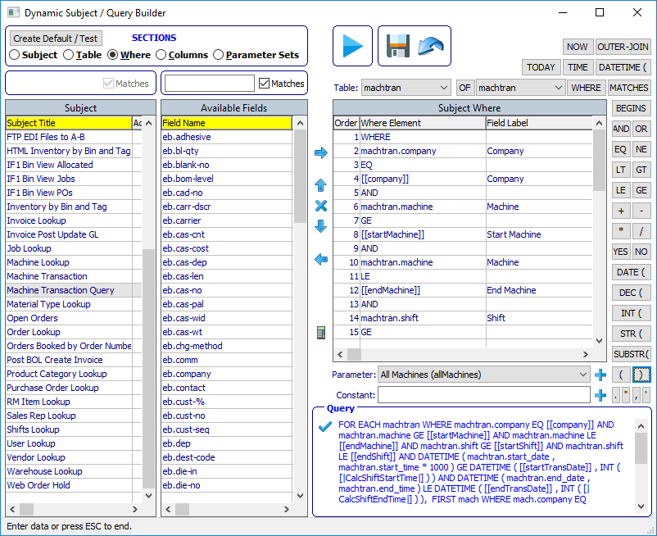
* Where clause is built here. The Subject Where entries are associated with the selected Table to the left of the “OF” button. To build multiple Where Clauses, change to the desired Table. Clicking any of the wrap around buttons on the top and right side of the Subject Where will auto enter the button text into the Subject Where. These are shortcut buttons for the most commonly used where clause components. If a short cut button does not exist, the desired component can be entered using Constant and Add Constant function (see below).
  + **Add Selections**  will add one or more of the selected Available Fields to the Subject Where or simply double click an Available Fields to auto add the field to Subject Where.
  + **Move Up**  will move the selected Subject Where up in the order.
  + **Remove**  will remove one or more of the selected Subject Where or simply double click a Subject Where to auto remove the selected where entry.
  + **Move Down**  will move the selected Subject Where down in the order.
  + **Remove Selections**  will remove one or more of the selected Subject Where or simply double click a Subject Where to auto remove the selected where entry.
  + 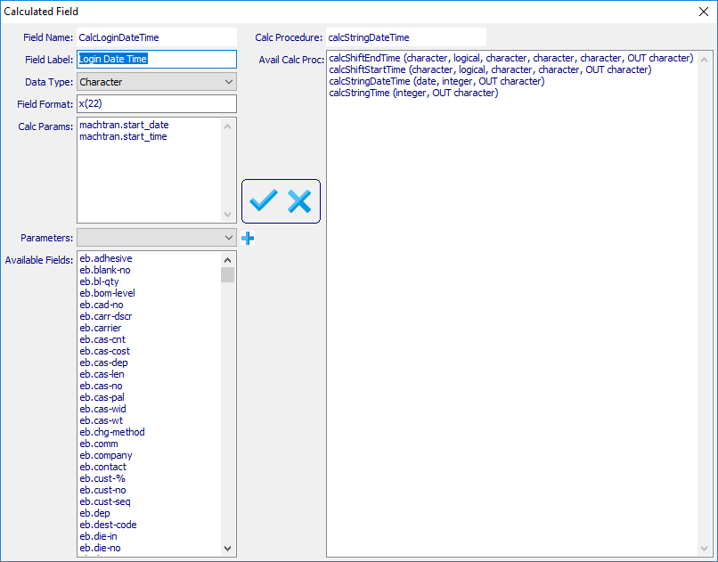
  + **Calculated Field**  facilitates the creation of a calculated field utilizing database fields in conjunction with developer created functions.
    - **Fields**
      * Field Name is auto generated based on the Field Label value entered, which always begins with “Calc” and the Field Label with any blanks removed.
      * Field Label is a freeform entry.
      * Date Type options are Character, Date, Decimal, Integer and Logical.
      * Field Format is a freeform entry and needs to be properly entered based on the Data Type.
      * Calc Params entries are made by double clicking any field found in the Available Fields selection list. Double click an entry to remove the field from Calc Params.
      * Parameters is populated with Parameter values from the associated Subject Parameter Sets and will add a selected Parameter using the add  icon.
      * Available Fields is populated based on the fields associated with a Subject’s query tables.
      * Calc Procedure displays the selected Avail Calc Proc.
      * Avail Calc Proc is a list of the procedures found within the SUPER-PROCEDURE AOA/spDynCalcField.p.
    - **Save**  performs a save of the values entered and exits this popup module.
    - **Cancel**  exits this popup module.
  + **Add Parameter**  will add a parameter to the Subject Where clause with [[ and ]] brackets. The list of available Parameters are derived from the Subject’s associated Parameter Sets.
  + **Add Constant**  will add the entered Constant value to the Subject Where clause and must be correctly formatted which may require beginning and ending quotes.
  + **Check Query Syntax**  will check the query syntax to expose any potential errors and should be done frequently to ensure a proper formatted query.
* 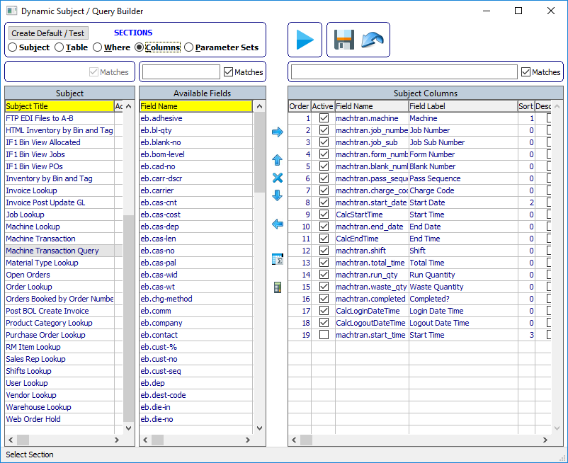
* Columns is where all the fields of the Subject Table(s) are made available to be selected as available columns.
  + **Fields** available to be changed within the Subject Columns browser
    - Active indicates if the column field will appear on as a result column.
    - Field Label allows for a value to overwrite the default value pulled from the database schema.
    - Sort allows for the selection of how the resulting data is sorted.
    - Descend indicates the column data will be sorted in descending order.
    - Group indicates the selected field can be used as a Grouping for Sub-Totally, Totaling, Averaging, Counts, Low Value, High Value and/or within a calculated field.
    - Group Label if populated with place a bolded label to the left of the columns.
    - Field Format is populated by default from the database schema but can be overwritten if the default is not the desired format.
  + **Add Selections**  will add one or more of the selected Available Fields to the Subject Columns or simply double click an Available Fields to auto add the field to Subject Columns. When adding a new field, Field Label and Field Format is auto populated from the database schema.
  + **Move Up**  will move the selected Subject Columns up in the order.
  + **Remove**  will remove one or more of the selected Subject Columns or simply double click a Subject Columns to auto remove the selected where entry.
  + **Move Down**  will move the selected Subject Columns down in the order.
  + **Remove Selections**  will remove one or more of the selected Subject Columns or simply double click a Subject Columns to auto remove the selected field entry.
  + 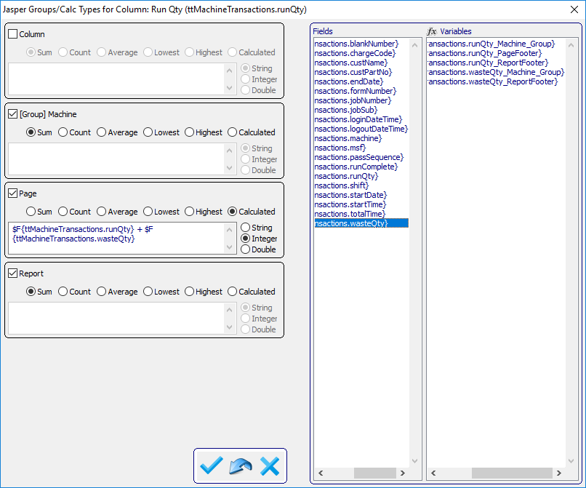
  + **Group Calculations ** will only appear when a Task’s User ID is NOT “_default”. There are three default Groups (Column, Page and Report). If any Column was designated as a Group, that Column will also appear labeled [Group] <Column Label>. In the above image, Machine was selected as a Group and appear as [Group] Machine for the Column Run Qty. Groupings have the option to Sum, Count, Average, Lowest (value), Highest (value) or Calculated. Calculated values can be of data type Character, Integer (non-decimal numbers) or Double (decimal numbers). When building a Calculated value, Fields and Variables are available. Simply place focus into the editor of the Grouping and double click a desire Field and/or Variable. This editor is freeform and requires the user to ensure properly formatted formulas. The nomenclature used for Fields $F{table.field} and Variables $V{table.field_group} is recognized by the Jasper Framework and is formatted to match the auto generated Jasper Report syntax.
    - Save  will save any changes entered and exit the popup.
    - Reset  will restore any changes values to their prior setting.
    - Cancel  will ignore any changes entered and exit the popup.
  + 
  + **Calculated Field**  facilitates the creation of a calculated field utilizing database fields in conjunction with developer created functions.
    - **Fields**
      * Field Name is auto generated based on the Field Label value entered, which always begins with “Calc” and the Field Label with any blanks removed.
      * Field Label is a freeform entry.
      * Date Type options are Character, Date, Decimal, Integer and Logical.
      * Field Format is a freeform entry and needs to be properly entered based on the Data Type.
      * Calc Params entries are made by double clicking any field found in the Available Fields selection list. Double click an entry to remove the field from Calc Params.
      * Parameters is populated with Parameter values from the associated Subject Parameter Sets and will add a selected Parameter using the add  icon.
      * Available Fields is populated based on the fields associated with a Subject’s query tables.
      * Calc Procedure displays the selected Avail Calc Proc.
      * Avail Calc Proc is a list of the procedures found within the SUPER-PROCEDURE AOA/spDynCalcField.p.
    - **Save**  performs a save of the values entered and exits this popup module.
    - **Cancel**  exits this popup module.
* 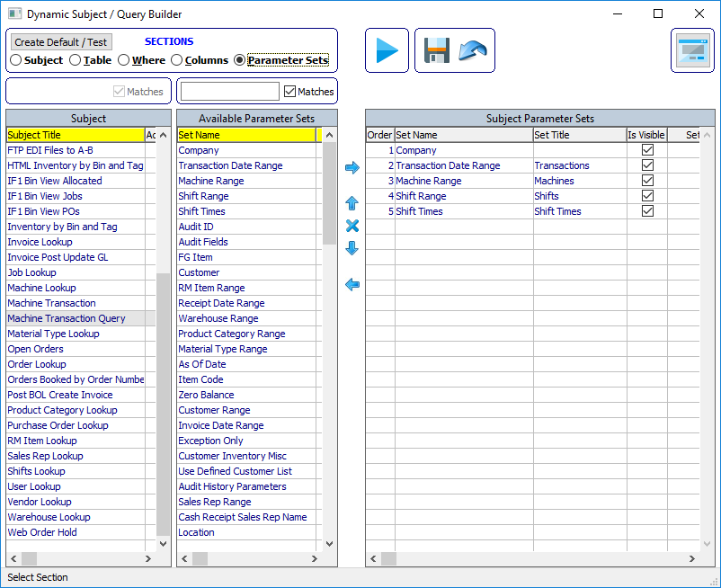
* Parameter Sets is the section where Dynamic Parameter Sets [ND3] can be associated with a Dynamic Subject. Unchecking the Is Visible column will hide the Subject Parameter Set to not be visible when the subject’s Dynamic Parameter screen renders. Any values for the parameter are applied from with the Dynamic Parameter Value record for the user.
  + **Add Selections**  will add one or more of the selected Available Parameter Sets to the Subject Parameter Sets or simply double click an Available Parameter Sets to auto add the field to Subject Parameter Sets.
  + **Move Up**  will move the selected Subject Parameter Sets up in the order.
  + **Remove**  will remove one or more of the selected Subject Parameter Sets or simply double click a Subject Parameter Sets to auto remove the selected entry.
  + **Move Down**  will move the selected Subject Parameter Sets down in the order.
  + **Remove Selections**  will remove one or more of the selected Subject Parameter Sets or simply double click a Subject Parameter Sets to auto remove the selected entry.
  + 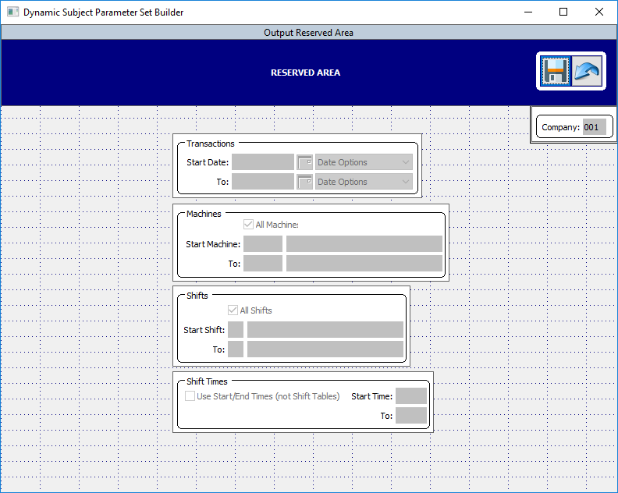
  + **Subject Parameter Set Builder ** is a WYSIWYG (what you see is what you get) builder for laying out Dynamic Parameter Sets associated with the Dynamic Subject. When adding a Dynamic Parameter Set it is auto positioned in the upper left corner at Column 1 Row 1. Simply drag and drop the Parameter Set to the desired screen position and perform a Save operation. Avoid placing any Parameter Set in the   
    Blue Reserved Area in the upper portion of the screen. This area is reserved for Email Recipients, Output icons and Show Toggle-Boxes.
    - **Save**  will enable if any changes are done to the set object(s) and Save those changes.
    - **Reset**  will enable if any changes are done to the set object(s) and Reset the prior position(s), then disable itself and the Save icon.
* 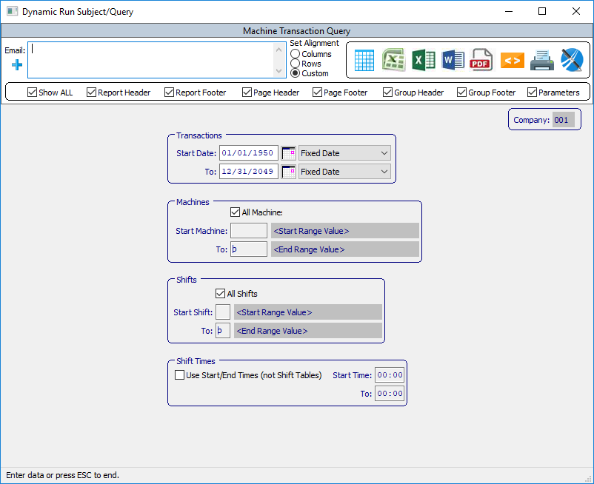
* Run Subject  will run the Dynamic Parameters screen associated with the Subject selected.
  + - 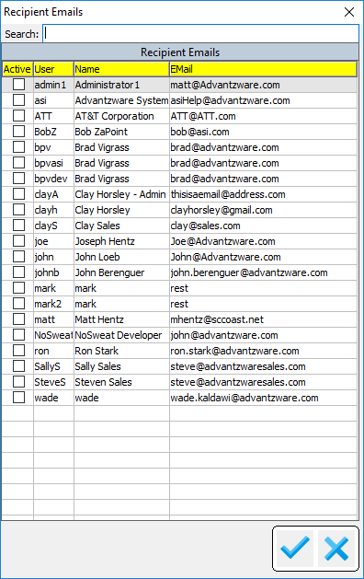
    - Email (recipients)  is a freeform field and relies on the user to enter email addresses properly formatted [*name@domain.com*](mailto:name@domain.com)*.* Clicking the “+” (plus sign) icon, the above popup is presented. It is populated with users (maintained in NU3 Users) which have an email field that is populated.
      * **Search** will auto locate and filter records that match the entered criteria found in the yellow labeled columns.
      * **Save** will auto display any Recipient Emails which have been selected via Active column that has been checked into the Recipients field. Any freeform emails entered will also appear and Active selected. Unchecking the Active column value will remove a freeform email.
      * **Cancel**  will close the Recipient Emails popup without applying any changes to the Recipients field.
    - Set Alignment has no current functionality, may be implemented in a future release.
    - Show [toggle boxes] allows for the various sections of the Jasper Report to be rendered. Show All will toggle all the values ON or OFF. The various sections include Report Header/Footer, Page Header/Footer, Group Header/Footer and if showing the Parameter values on the last page is desired.
    - 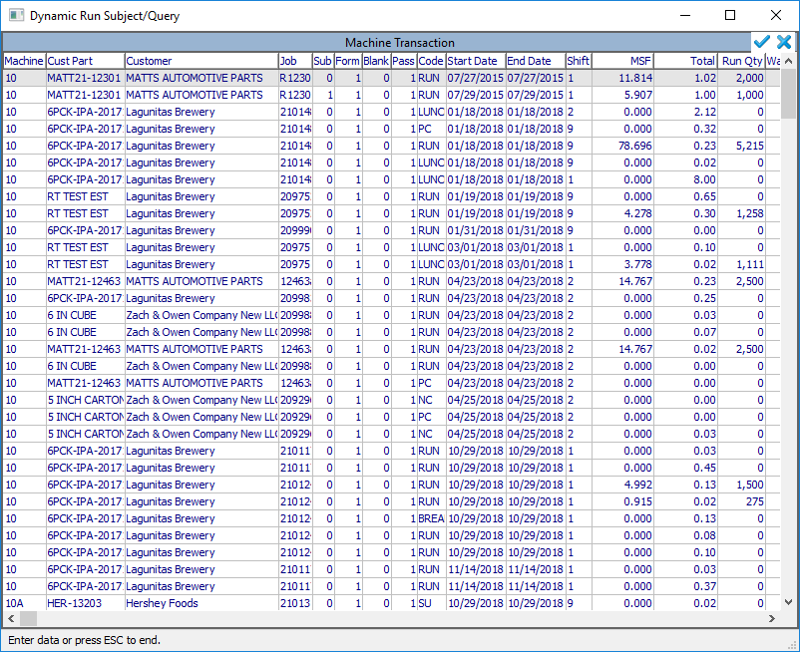
    -  Grid renders the dynamic query results to a grid browser. Columns can be re-arranged and column widths can be re-sized and saved.
      * Save  will Save any column order and width changes.
      * Cancel  will close the Grid and return to the Parameter screen.
    - Note: when selecting any of the next five options (CSV, XLS, DocX, PDF, HTML) the Task is submitted for processing by the Task Monitor and will prompt with:
    - 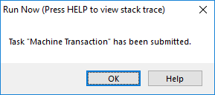
    -  CSV creates an Excel CSV Task Result.
    -  XLS creates an Excel Task Result.
    -  DocX creates a Word Task Result.
    -  PDF creates a PDF Task Result.
    -  HTML creates a HTML Task Result.
    -  Printer invokes the Windows Printer Dialog popup.
    - 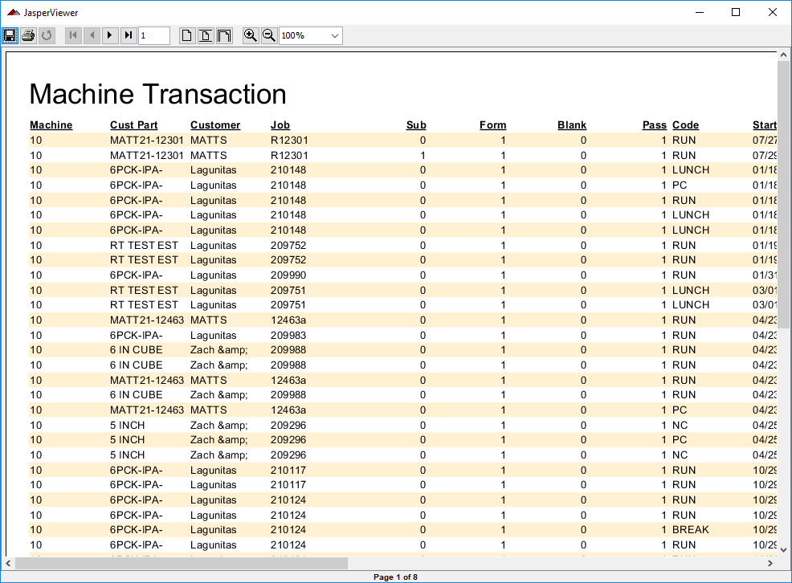
    -  Jasper Viewer will run the query results to Jasper Viewer if Jasper Starter is installed locally. When a Viewer session is invoked, a background command window renders and will remain open until the Viewer is closed.
    - 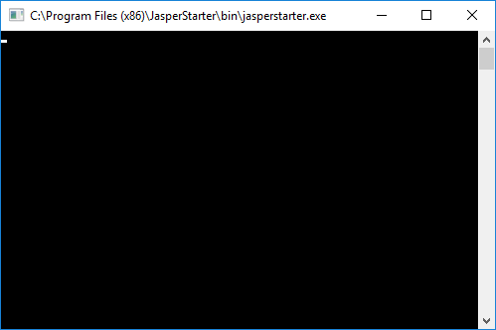
    - Viewer command window.
    - 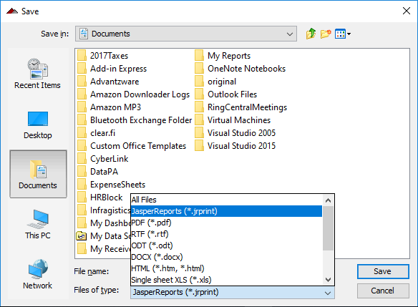
    - Viewer allows the user to Save the results into various formats.
    - 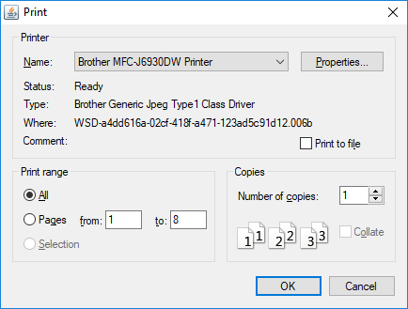
    - Viewer has ability to select and send results to a printer device.
    - Easily navigate to First, Previous, Next, Last Page.
    - 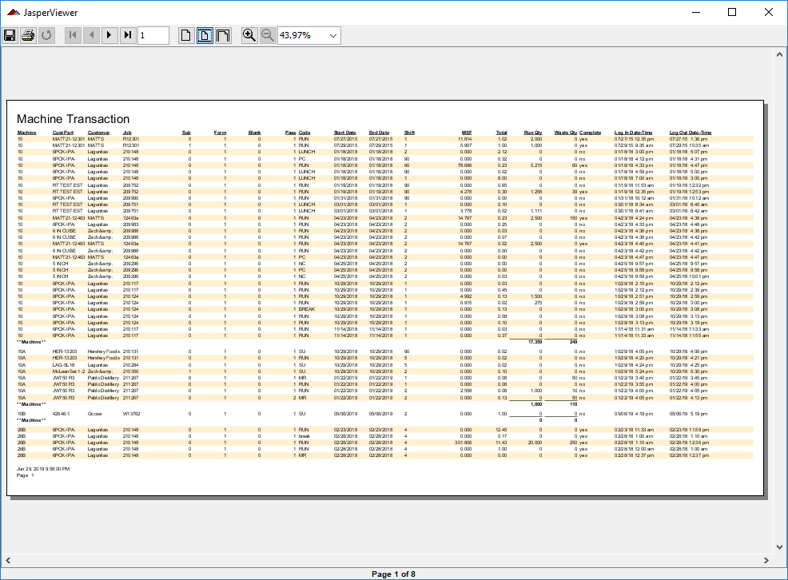
    - Results can be auto sized to fit the Viewer
    - Viewer has functionality to zoom in/out and/or set the display relative percentage size.